The Miracle Of Prayer

This is the day the Lord has made. We shall be glad and rejoice in it.

Miracle definition
An extraordinary and welcome event that is not explicable by natural or scientific laws and is therefore attributed to a divine agency. “ the miracle of rising from the grave”.

Prayer definition
A solemn request for help or expression of thanks to God or another deity. “ I’ll say a prayer for him”.

What I like about the definition Oxford definition of prayer is that it points to God and a singular entity and then states “ or another deity”.

So from the Oxford definition, the miracle of prayer can be summarised as;

“ An extraordinary and welcome event that is not explicable by natural or scientific laws and is therefore attributed to a solemn request for help or an expression of thanks addressed to God”.

Since joining MAGH and finding a spiritual home at KC, I have been witness to numerous miracles through prayer. In this message today, I will focus on one of these miracles with the intention to give testimony to reveal God’s majesty and proclaim His glory.

Prayer Point 1.
We pray for those we know in our lives who require the “welcome event” whether it be healing, restoration, comfort, providence or protection. Thank you Father for receiving these prayers IJN.

Prayer using the Word of God

Philippians 4:6
Be anxious for nothing, but in everything by prayer and supplication, with thanksgiving, let your requests be made known to God;

James 5:14-16
Is anyone among you sick? Let him call for the elders of the church, and let them pray over him, anointing him with oil in the name of the Lord. And the prayer of faith will save the sick, and the Lord will raise him up. And if he has committed sins, he will be forgiven. Confess your trespasses to one another, and pray for one another, that you may be healed. The effective, fervent prayer of a righteous man avails much.

Psalm 107:28-30
Then they cry out to the LORD in their trouble,
And He brings them out of their distresses.
He calms the storm,
So that its waves are still.
Then they are glad because they are quiet;
So He guides them to their desired haven.

John 14:13-14
And whatever you ask in My name, that I will do, that the Father may be glorified in the Son. If you ask anything in My name, I will do it.

Matthew 21:22
And whatever things you ask in prayer, believing, you will receive.”

Matthew 7:7
Ask, and it will be given to you; seek, and you will find; knock, and it will be opened to you.

Mark 11:24
Therefore I say to you, whatever things you ask when you pray, believe that you receive them, and you will have them.

Numbers 6:24-26
The LORD bless you and keep you;
The LORD make His face shine upon you,
And be gracious to you;
The LORD lift up His countenance upon you,
And give you peace.” ’

Miracle of Prayer: Baby Jahseh

For me, nothing comes close than praying for a baby, either your own or someone else’s. In our connect group we have a young, single mother who’s eight month old had critical open heart surgery recently. There was a 50/50 chance that baby Jahseh would not survive.

Suffice to say, we have been praying earnestly for baby Jahseh, day and night.

My wife and I were asked to visit the mother in hospital two Sunday’s ago. She was exhausted, both physically and spiritually and required prayer. Baby Jahseh had been in a post op sedation for about 12 days at that time.

We were serving at KC in the connect lounge when the message came through and we both simultaneously agreed to go by 3pm.

Throughout the day we had been physically crying and praying for the baby.

As we arrived, mum rushed out to say they had just woken Jahseh at 3pm exactly. She was ecstatic and we went to his room. Here is a picture of baby, two Sundays ago.

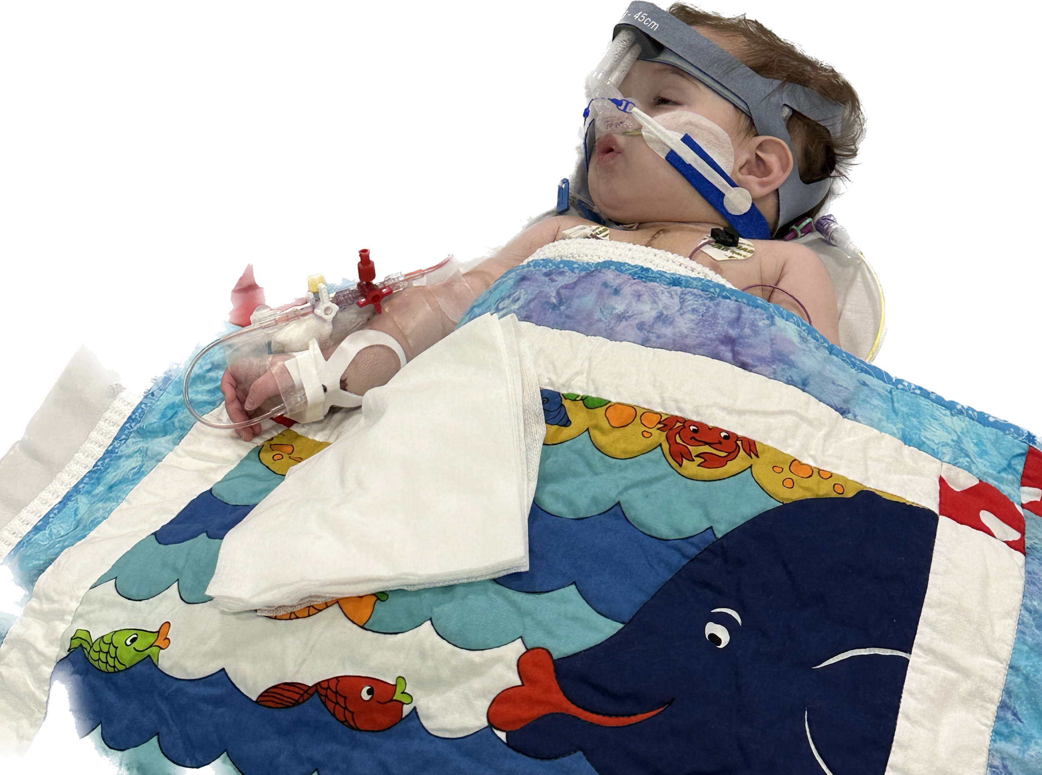

The attending clinical team were preparing to perform an echocardiogram when I asked if we could pray over the baby, seeing he was awake and ready to receive a blessing!

They waited patiently and when I finished praying, all were smiling. It felt as though they thought anything could help.

During the past two weeks we have asked over 100 people to pray including the prayer warriors here at MAGH.

And our prayers have been answered.

This is the photo of Jahseh on Easter Monday a few days ago.

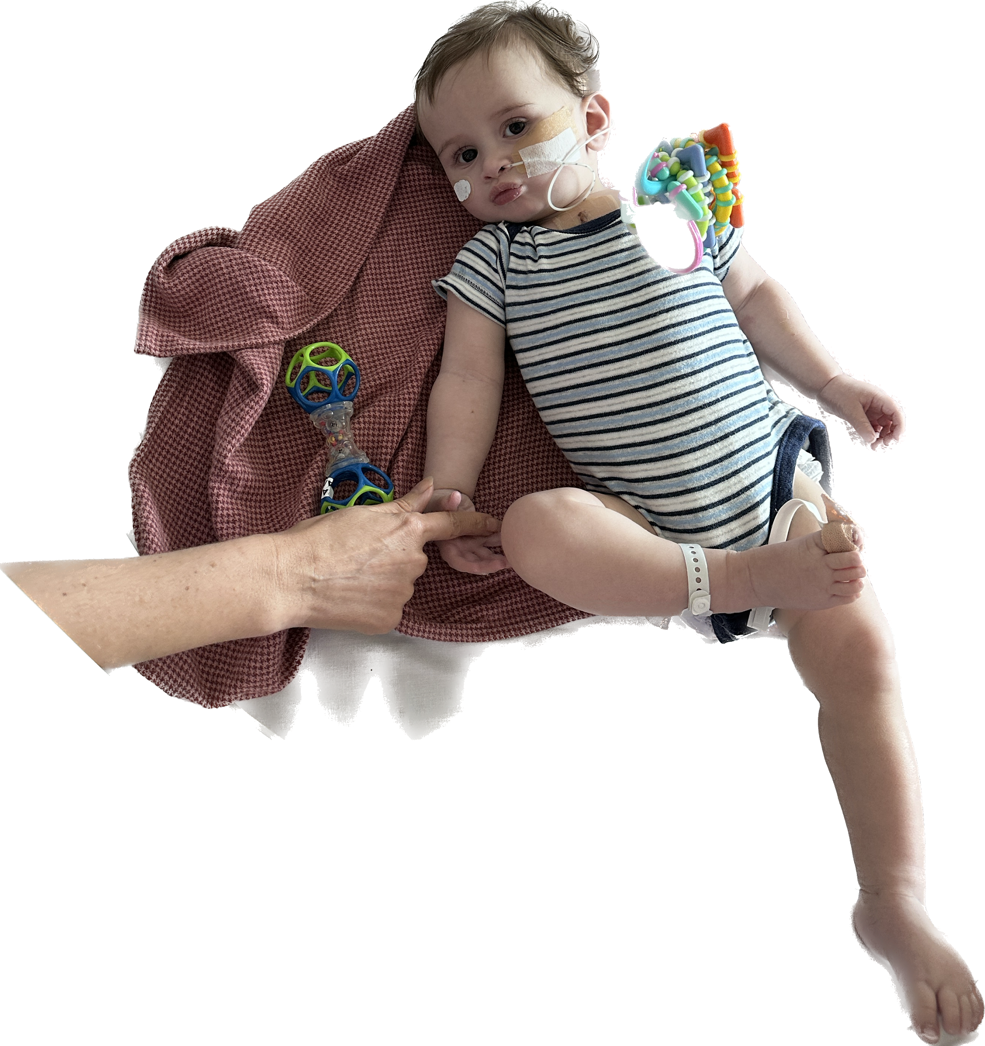
The medical team stated that Jahseh was progressing very fast. The nurse assigned to the baby was also baptised at KC on Easter Sunday! Can you believe it. Praise God.

Mothers praise report received during our Wednesday Connect night

“Okay family we are finally home! For all those who have prayed for our bubba let me share with yous all that god has done for him 😊

1. Heart surgery was a success, after 2 weeks of intense care, he was finally woken up and recovered very quickly over the Easter weekend 🙌🏽
2. NO MORE VOMITS - jahseh used to vomit everyday big vomits at least three times per day. He has not had ANY vomits or gagging since post op. Praise the lord!
3. NO MORE MEDS - we are weaning him off some antibiotics for a week then we’re med free. Jahseh used to have to take meds 7x per day 🥹
4. No more worrying about his weight - feed times can now be focus on positive learning for baby and next step will be to get the tube out 🥰

Multitudes have been lifting jahseh and I up in prayer from our church. Hundreds of people gave their lives to Christ over the Easter weekend if not thousands! My spiritual parents came to visit us twice and pray for baby also.

God is so so good. Ofc I had to share the victories God sees and hears amen and amen 😍🥰❤️”

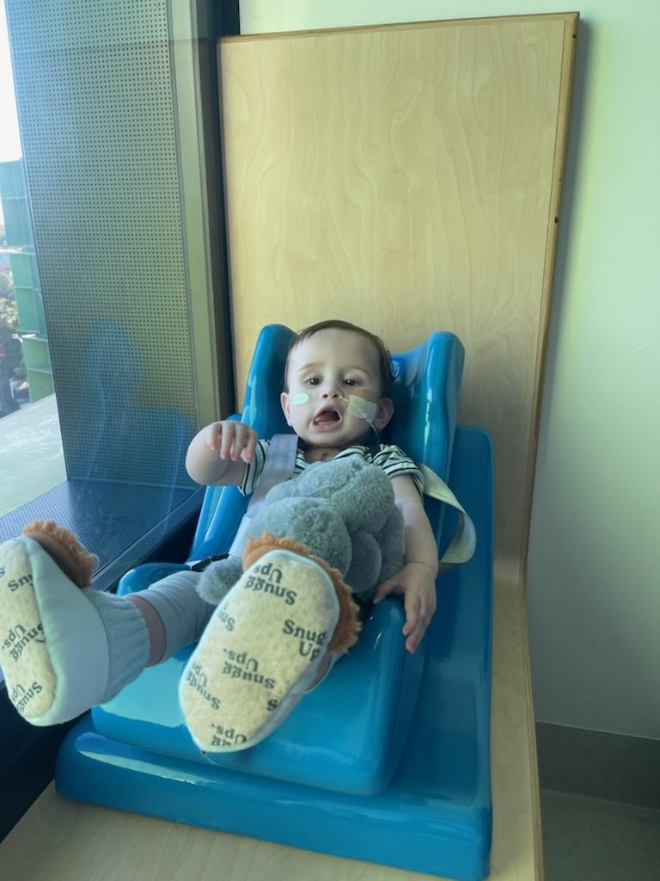

This my dear warrior brothers is the miracle of prayer at work. I have no doubt that our Father God has heard our supplication and healed this child.

Prayer Point 2.

Father God, we pray over our children and of those in need of healing. They are Your sons and daughters and the love You have for them far surpasses our own. Keep them protected and provided for, all the days of their lives and may they in turn seek you with open arms and call You Abba Father.

Prayer Point 3.

Heavenly Father, we give thanks and praise for the miracle of answered prayers. We come with repentance and faith to witness the promises you keep for our lives.
We submit to you dear Father and do Your will, all the days of our lives.

Ps Lakers

